PROFILE
• Enterprise architect and delivery leader with 35+ years across public services, consulting, rail, data platforms and software product development.
• Senior leadership of architecture, delivery and engineering teams, including P&L, sales support, bids and tenders, suppliers, programme recovery and delivery assurance.
• Extensive UK Government experience across HMRC, Government Digital Service, Government Property Agency and the British Library; architecture practice development, transformation and interim leadership.
• Board-level adviser and technical delivery lead, connecting roadmaps and commercial decisions to implementation, with onshore and offshore team leadership.
• Hands-on architecture and engineering across cloud integration, customer data platforms, SQL Server, migration, operational tooling and governed AI and LLM systems.
• Sole architect and developer of Rosetta, a delivery, management and support platform bringing together integration, data, workflows, reporting and AI-assisted operations.
• Practical use of TOGAF, IAF and Zachman across Agile, MSP, PRINCE2, RUP and Waterfall delivery. Career foundations include commercial games, languages, compilers and development tools.
TECHNOLOGY SUMMARY AND INDUSTRY EXPERIENCE
Infrastructure and OS  Azure, AWS, Docker, Linux, Windows Server, Unix, HP-UX, VMware, OpenStack, networking and IoT.  Front End and Development  React, Node.js, Express, Fastify, Python, .NET, C#, Java, C/C++, PowerShell, shell scripting, web and mobile technologies.  Databases  SQL Server, T-SQL, PostgreSQL, Oracle, Sybase, MySQL, MariaDB and MongoDB. | Integration and Middleware  ETL, REST APIs, S3, SFTP, RabbitMQ, Redis, Socket.IO, Node-RED, WebMethods, Salesforce and Office 365.  AI and Governance  Ollama, local CPU/GPU serving, RAG, Qdrant, embeddings, semantic SQL, prompt governance, RBAC, LDAP, PII controls and runtime telemetry.  Architecture and Delivery  TOGAF, IAF, Zachman, Agile, MSP, PRINCE2, RUP, Cloud First, roadmaps, GDPR and service transition. | 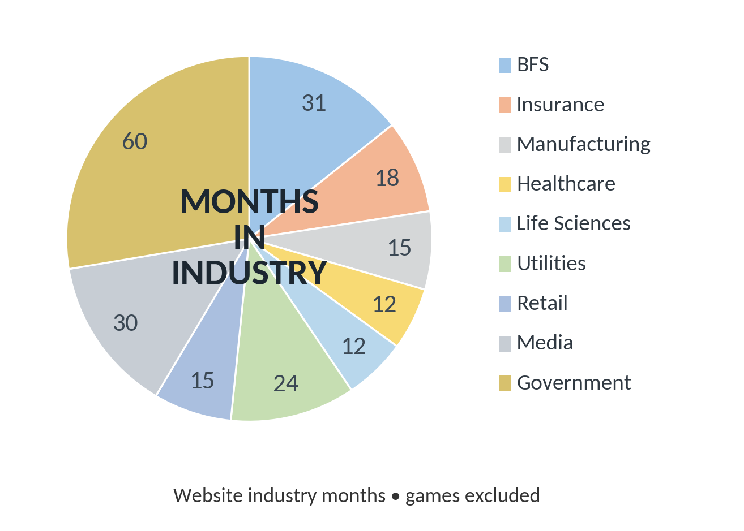  ~150 months previously in Computer Games
RECENT CAREER SUMMARY
Date | Type | Company | Role
2024 - Present | Contract | Altcom Ltd | Head of AI
2023 - 2026 | Product | Rosetta | Architect and Product Owner
2023 - 2024 | Contract | Paddy Power Betfair | Data Scientist / Enterprise Delivery
2020 - 2023 | Contract | Altcom Ltd | Head of Data Architecture
2019 (3m) | Contract | British Library | Interim Head of Architecture and Design
2019 (6m) | Contract | Government Property Agency | Enterprise Architect
2017 - 2018 | Contract | Government Digital Service | Head of Technical Architecture
2015 - 2017 | Contract | Cubic / Abellio ScotRail | Enterprise Architecture and Delivery
2014 - 2015 | Perm | Mindtree | Head of European Architecture
2008 - 2014 | Perm | Cognizant Technology Solutions | Head of European Technology Consulting
2004 - 2008 | Perm | Capgemini | Lead Architect / Interim Lead Architect
2003 - 2004 | Perm | Enigma Interactive | Head of Development
1999 - 2003 | Perm | Accenture | Technical Architect
1988 - 1999 | Contract | Computer Entertainment Industry | Innovator, Manager and Developer



CAREER HISTORY
Altcom Ltd – Head of AI January 2024 to Present
Lead AI and data architecture work for Altcom while continuing the development, support and commercial planning of the Greater Anglia Customer Data Platform. Combine solution architecture and client advisory work with hands-on T-SQL engineering, integration design and operational analysis.
• Develop the 2026/27 CDP roadmap, estimates and proposals covering data ingestion, platform maintenance, customer preferences, retention, deletion and integration modernisation.
• Extend daily ingestion and customer segmentation across Trainline SGP, GoldStar, railcards, Rail Plus and train Wi-Fi data, with coordinated exports to Dotdigital and preference synchronisation.
• Analyse customer accumulation, weekly patterns and import volumes to identify Wi-Fi-driven growth and prepare 18-month capacity recommendations for Dotdigital.
• Design an email-code authorisation proposal for the preference centre and automated right-to-be-forgotten workflow following changes to Trainline login integration.
• Develop SQL data profiling, metadata, dependency analysis and validation tooling, alongside practical AI support and automation approaches.
Rosetta – Architect and Product Owner 2023 - 2026
Designed and developed Rosetta as the sole developer: a delivery, management and support platform for software delivery and operational teams. The platform brings together data access, schema and metadata tools, process design, reporting, files, services and governed LLM support.
• Built the React and Node.js application with SQL Server persistence, Redis runtime coordination, RabbitMQ job execution and Socket.IO streaming; integrated databases, S3, SFTP, SMTP and Python execution.
• Implemented AI Chat and support workflows with controlled prompt sources, role-based access, PII-sensitive controls and durable runtime telemetry. Supporting work includes RAG, embeddings, metadata filtering and semantic SQL generation.
• Developed local and distributed Ollama model-serving orchestration using CPU/GPU workers, RabbitMQ transport, Redis coordination, cancellation and Docker deployment assets.
• Designed the separation of Rosetta administration, Gateway integration and protocol hosting, and CoolOps deployment, monitoring and container management. Defined common metadata, logging and event requirements across distributed nodes.
• Designed optional local Gateway queues and RabbitMQ federation to keep local traffic local, alongside distributed AI and Python execution across networked machines.
• Extended process tooling through spreadsheet-style calculation, time-series and ML workflow design, and failure quarantine and recovery. Developed LLM-assisted T-SQL validation and repair tooling with isolated validation stages.
Paddy Power Betfair – Data Scientist and Enterprise Delivery January 2023 to January 2024
At Paddy Power Betfair (PPB), I was tasked with revitalising a legacy internal communication system critical to betting transactions across global sports. Developed over several decades, the system was difficult to use or extend because of its technology, inconsistent structures, high throughput and evolving data objects.
I developed a proof of concept to manage the full lifecycle of betting events, then led the business tender process, solution design and proposal. My role expanded from data science into enterprise delivery and database implementation. I introduced data compression between operational ingress and database egress to reduce internal platform bandwidth, lower costs and improve performance, alongside database-centric processing.
The delivered cloud solution used AWS, Node.js and bespoke data lifecycle management in Microsoft SQL Server. REST APIs, S3 object buckets and middleware abstracted the underlying PPB messaging system and supported integration by internal and third-party services.
Delivered a scalable, extensible Platform as a Service foundation for modernisation and future integrations.
Altcom Ltd – Head of Data Architecture January 2020 to December 2023
Architected the Altcom Customer Data Platform for Abellio train operating companies, covering marketing, business intelligence, data warehousing, archiving and Single Customer View, with enterprise integration and file/data transfer capabilities. Designed migration and data cleansing from the incumbent platform, and managed implementation of multiple provider schemas, account-based extracts, schema migration, a replacement GDPR data-owner platform and a new CRM data source.
Established an ongoing relationship between Gala Arch Ltd and Altcom Ltd through negotiated intellectual property and royalty arrangements. Continued ownership of the data architecture responsibilities forms part of the subsequent Head of AI role.
British Library – Interim Head of Architecture and Design September 2019 to December 2019
Provided interim leadership after the architecture and design team had been without a leader for six months. Introduced a new recruitment approach and interview scoring methodology aligned with the Civil Service competency framework, initially for lead architects and applicable across digital functions. Defined the initial technology roadmap and reduced projected storage requirements for the perpetuity database from 27PB to less than 10PB. Instigated supplier reviews and worked with the senior leadership team to address shortfalls in supplier value.
Government Property Agency – Enterprise Architect January 2019 to July 2019
As the agency’s sole architect, I defined application and data architecture and worked with the board and new CEO on the technology enablement roadmap. Supported Smarter Working across the Cabinet Office and wider government, using Google, Azure and Salesforce cloud platforms. Developed a historic-building sensor proof of concept to inform building strategies, covering networks, PIR sensors, lifts, entry gates and desk sensors. Responsibilities ranged from board presentations and financial modelling to technical coding and physical infrastructure integration.
Government Digital Service – Head of Technical Architecture October 2017 to December 2018
As a Senior Civil Servant and member of the leadership team, I helped restructure Delivery and Support from siloed teams into four towers covering GOV.UK, Verify, Technical Operations and Government as a Platform. Established an architecture practice and hierarchy, developed grading structures with the Cabinet Office, and recruited and promoted architects into a GDS-wide cohort. Supported The GDS Way, API Standards, Open Source for Government and Build2Share with HMRC, the Cabinet Office and the Home Office. Ran architecture assessments and technical refresh programmes to support Cloud First and platform re-platforming. Led implementation strategy and worked with economists on Spending Review 2019 options for the proposed 2020–2025 restructuring.
Cubic with Abellio ScotRail – Enterprise Architecture and Delivery August 2016 to September 2017
Part of the pre-sales team that won the approximately £10m Enterprise Integration Platform and Account Based Ticketing programmes. Led architecture, technical delivery and project management from conception to service transition. Designed an Azure-based platform integrating Abellio ScotRail and its vendors, extending the scope to a central customer database, authentication and authorisation, and ETL of Trainline and Rambus data. Extended the ScotRail retail website to support Account Based Ticketing, building on the Cubic platform developed during the preceding engagement.
Cubic Transportation Innovation – Enterprise Architecture and Delivery June 2015 to July 2017
Oversaw development of Cubic’s Transportation Management System, originally NextTraffic, in partnership with Microsoft. Created a cloud-agnostic platform framework and Physical Abstraction Layer to connect legacy road equipment to cloud services, with real-time integration from multiple traffic sources. The initiative was presented at transportation shows and world congresses. Supported RFPs, tender submissions and pre-sales across transportation, culminating in the ScotRail Enterprise Integration Platform and Account Based Ticketing wins.
Won the Cubic Disruptive Innovation Award 2016 for autonomous sound detection and analysis linked to CCTV control for public-space incident review.
Mindtree – Head of European Architecture June 2014 to March 2015
• Technical sales lead contributing to the largest net-new deal of 2015.
• Office365 migration and desktop standardisation across 86 offices
• Strategic impact assessment of a large digital transformation for a leading manufacturing company
• Thought leader in two digital innovations within the retail and the car industry
• Presales through to delivery remit to drive continuous quality improvement
Cognizant – Head of European Technology Consulting August 2008 to May 2014
• Consulting project portfolio exceeded $200m in total revenue, with client accounting totals exceeding multiple billions of dollars per year.
• Lead Architect for the Financial Services Authority, opening a new client relationship that generated $6m over three years from the initial engagement.
• Led cloud suitability assessments across multiple sectors and developed an assessment tool to shorten analysis of infrastructure, services and software across cloud options.
• Managed P&L, practice budgets, projections and growth strategy for an expanding European consulting practice.
• Led product partnerships, including VMware, and collaborated with Red Hat on the open-source SAVARA project for solution architecture tooling.
• Created architecture and governance innovations including enterprise architecture lite, service cost view and automated governance, alongside systemic defect profiling and testable integration architecture.
• Chief Architect for a media organisation consolidating 18 data centres into two. Led due diligence that secured an award without tender; the initial project exceeded $2m in revenue.
• Validated and estimated a £30m, five-year IT transformation for a specialty insurer, reporting to the CIO and managing offshore support to produce the evidence for investment decisions.
• Chief Architect for a major broadcaster’s IT infrastructure transformation and support programme, coordinating 15+ technology and operations towers and providing solution, bid and commercial leadership.
• Lead Consultant on NHS and Boots hackathons addressing patient-data use and digital innovation on the shop floor.
• Led performance improvement and stabilisation of COTS and bespoke systems across Windows and Unix, including greenfield and legacy programmes in banking, financial services and energy.
• Directed onshore and offshore architectural reviews and remediation plans, and chaired executive initiatives addressing delivery targets, service levels and project recovery.
• Redesigned presentation, business, integration and data architectures for global applications, including communication protocols, third-party accelerators and Oracle-to-Microsoft migrations; provided specialist infrastructure and service advice.
Capgemini – Lead Architect July 2004 to July 2008
Led the architecture team at Capgemini’s HMRC Newcastle site across a portfolio with more than £50m total cost of ownership. Accountable for Child Trust Fund, New Tax Credits Authentication, NIRS2, Health in Pregnancy Grant and Savings Gateway tender work. The Child Trust Fund role supported a public programme that put more than £1bn into children’s savings accounts. Delivered across multiple revenue streams with high customer satisfaction and profit margins, zero slippage and zero major defects on transition into production.
Led service-oriented architecture and enterprise application integration across 500+ services, including WebMethods ESB strategy, Child Benefit 2 migration and decommissioning, and Child Trust Fund enhancements. Introduced architecture governance and Agile delivery practices; reduced the defect rate from one per £16k of budget to one per £720k.
Capgemini – Interim Lead Architect March 2004 to June 2004
Designed migration rules and controller software for automated conversion of more than 90 million lines of code from HP-UX 10.20 to HP-UX 11i using POSIX kernel threading, preserving the semantic integrity of NIRS2. The migration covered third-party interfaces including DCE, Sybase, Rogue Wave and Bolden James, alongside the hardware platform migration. Automated code conversion required no human intervention. Planned installation, configuration and integration of live, disaster recovery and non-live environments across 86 servers.
Enigma Interactive – Head of Development July 2003 to March 2004
Head of development, designing and developing a Java audio-conversion solution for 1.5TB of music supplied as broadcast WAV files. The solution substantially reduced storage hardware requirements and enabled production units costing less than £15,000.
Designed and developed the software technology for providing high-availability and high-redundancy web presence across multiple machines. Geographical load balancing and remote system maintenance allows multiple worldwide servers to act as a single entity from the user and client’s perspective.
Designed and led creation of a Site Development Kit giving designers a GUI for generating database-driven Linux/ColdFusion websites. More than halved development time and improved code stability, reserving engineering effort for specialist modules. Sourced hardware and co-location services and supervised installation of complete server solutions and high-capacity drive arrays.
Accenture – Technical Architect December 1999 to June 2003
Designed tools to translate legacy NIRS2 database information into Excel spreadsheets using C++ header files and a bespoke control language. Supported bidirectional translation between non-technical reports and formatted transactions.
Liaised with Benefits Agency clients on system changes, data integrity and NIRS2 refinements. Covered the full lifecycle of design, documentation and technical assurance for development and testing in HP Unix scripts, C and Sybase.
Computer Entertainment Industry – Innovator Developer and Manager 1988 to 1999
Career progressed from commercial games for Atari 8-bit and Commodore 64 through Atari ST, Amiga, PC and PlayStation 1. Delivered complete titles and led small development teams, with responsibilities spanning architecture, core code, tooling, performance and production.
Selected titles and tools: Graeham Souness Vector Soccer, F1 Tornado, Popeye 2, Huckleberry Hound, 1994 Lillehammer Winter Olympics, Monster Trucks, GameMaker and ethosBasic. Designed and developed two integrated development environments and three languages, including compilers and interpreters.

